Complaints
We operate a stringent complaints policy, a copy of which can be collected
from reception. We accept complaints in writing, by telephone and in
person. Complaints should be directed to the Practice Manager.

Patient rights & responsibilities
We ask our patients to:
- Be courteous to GPs and practice staff at all times
- Be punctual for appointments
- Cancel any appointment you are unable to attend
- Be patient if the Dr/Nurse is running late

Patients can expect:
- To be treated with dignity and respect
- To be treated with a professional standard of care
- That your confidential information is kept safe and secure

Zero Tolerance
Springvale Medical Practice operates a zero tolerance policy against all
forms of abuse and/or violence including verbally abusive behaviour.
Failure to adhere to this policy may result in being removed from the
practice list.

Confidentiality
The practice adheres to Data Protection legislation. Identifiable information
about you may be shared with others in the following circumstances:
- To provide further medical treatment e.g. from District Nurses/Hospitals
- When we have a duty to others e.g. child protection

Anonymised/Pseudonymised patient information may be shared with the
Health and Social Care Board (HSCB) when requested for statistical analysis/strategic planning.

Reception and administrative staff require access to your medical records
in order to do their jobs; they are bound by the same rules of confidentiality
as the clinical staff.

Please refer to our privacy policies at www.springvalemedicalpractice.co.uk for further information

HSCB
12-22 Linenhall Street
BELFAST
BT2 8BS
Tel: 0300 555 0115

463 Springfield Road, BELFAST, BT12 7DN
Tel: 028 9032 7126
www.springvalemedicalpractice.co.uk

GPs
Dr A Leavy MB BCh 1976 QUB (F)
Dr R O’Kane MB BCh 1997 QUB (F)
Dr D Rigney MB BCh 2006 QUB (F)
Dr A Harper MB BCh 2005 QUB (F)

Practice Managers
Nicola Cummings
Deborah Watson (Assistant)

Opening Hours
9am – 12.30pm Monday, Tuesday, Wednesday & Friday
1.30pm – 6pm Monday, Tuesday, Wednesday & Friday
9am – 12.30pm Thursday

Out of Hours (OOHs)
6pm – 8.30am Monday – Thursday
6pm Friday – 8.30am Monday
& Bank holidays
Tel: 028 9074 4447

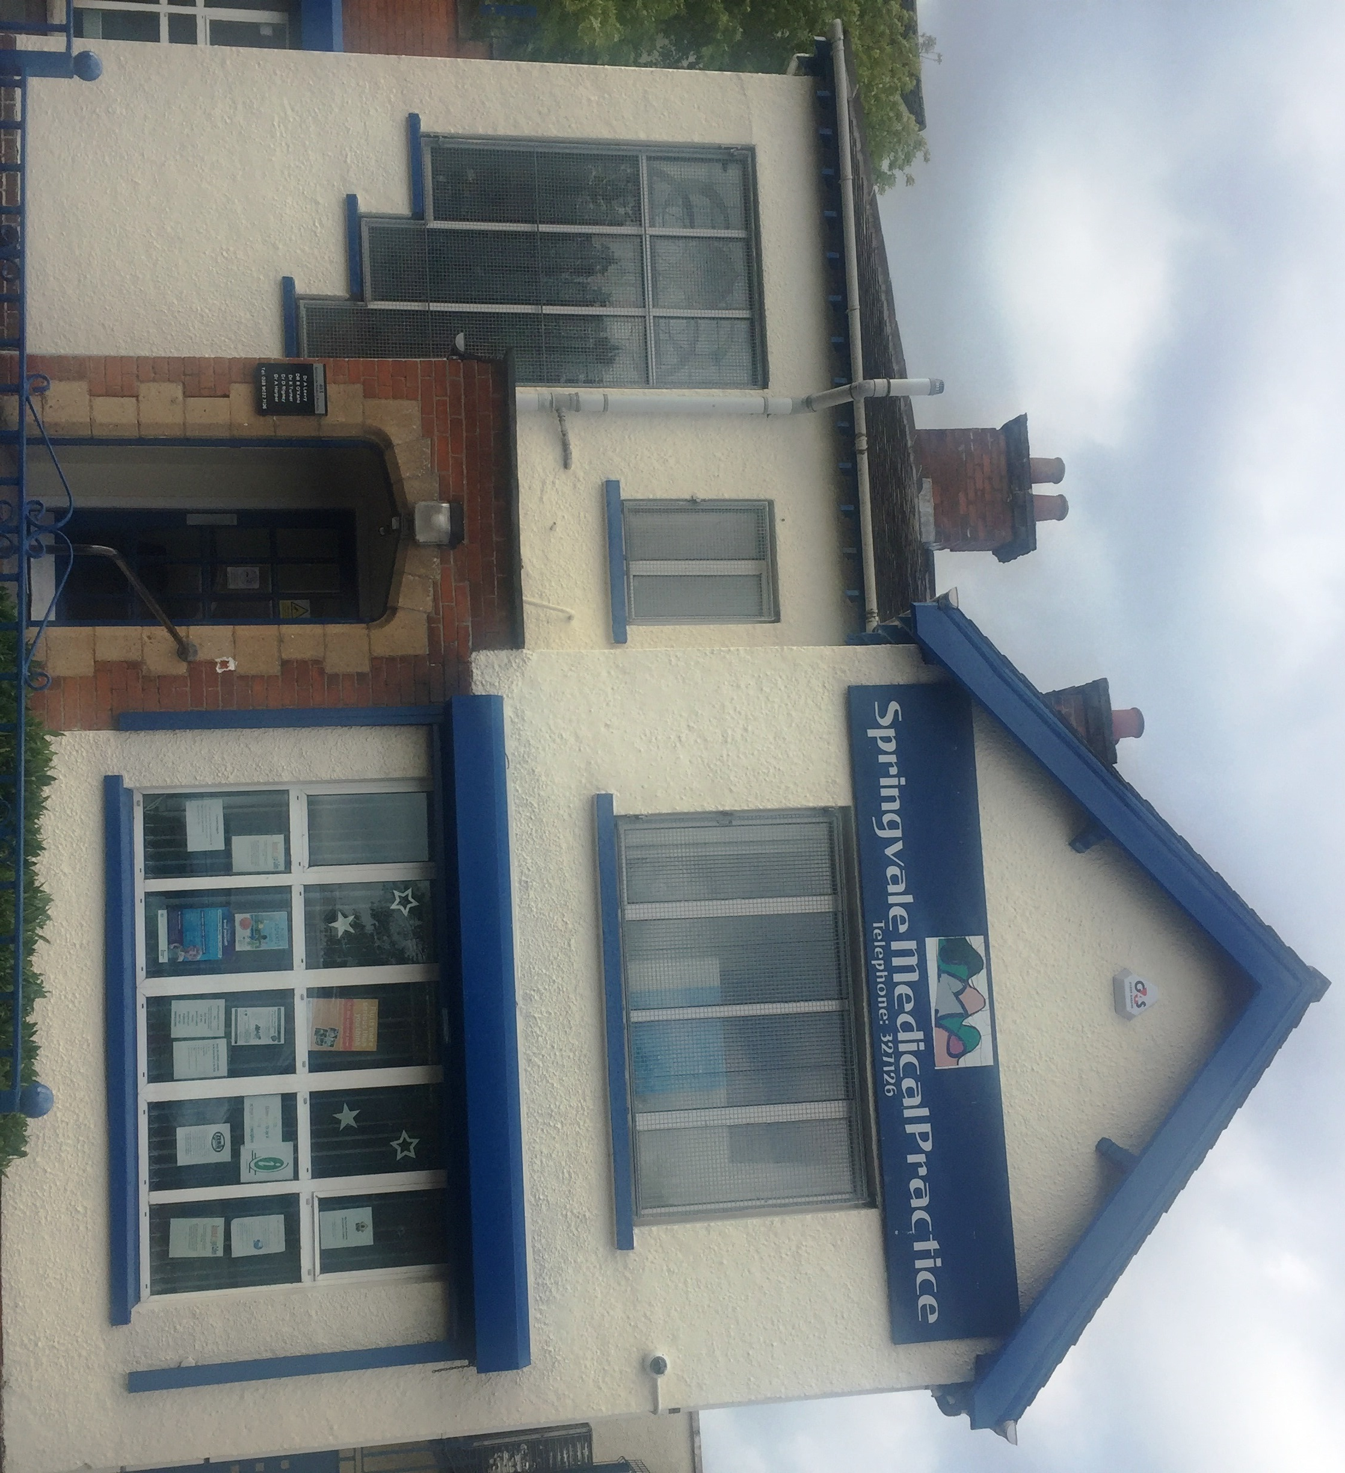

How to register
We accept new patients who live within our practice boundary i.e. a radius
of 5 miles, excluding patients residing east of the River lagan

Patients wishing to register can collect a registration form from reception.
You will be required to provide photographic ID and proof of address and
you will be invited to book a new patient registration appointment.

Appointments
We operate a telephone triage system for all appointment requests. Patients are asked to give brief details to the receptionist who will direct all calls to the appropriate clinician who will return your call and arrange a face to face appointment if required.

We have a multidisciplinary team in the practice comprising GPs, Nurses (including an Advanced Nurse Practitioner), Physiotherapists, Pharmacists and a Mental Health Practitioner.

Please refer to our website for further details.

Test results
Patients can ring for test results after 11am.

Home visits
Home visits are available for very elderly or housebound patients.
Requests should be made before 10.30am

Prescription requests
Our preferred method of receiving repeat prescription requests is via our online system. Please contact reception for further details or see our website.

Alternatively, we have an automated telephone service for repeat prescription
requests that can be accessed by telephoning the surgery and choosing
option 1.

Repeat prescriptions will be available to collect after 2 working days.

Prescriptions will be delivered to the pharmacy of your choice.

Antibiotic requests
Antibiotics will not normally be issued over the telephone. Patients will usually need to be seen by a GP first.

Clinics
Baby clinic Wednesday morning by appointment only
Family planning Wednesday afternoon by appointment only
Diabetes Monday afternoon by appointment only
Asthma Thursday morning by appointment only
COPD Wednesday morning by appointment only

Patients over 75 years of age
If you are over 75 years of age and have not been seen by a GP in the past 3
years we recommend that you book an appointment for a general health check.

Training Practice
Springvale Medical Practice is an accredited training practice and Dr Rigney is the
GP Trainer. We have GP Registrars working in our practice for up to 12 months
at a time.

Disability access
We have various measures in place to help ensure our surgery is accessible to
disabled patients including ramped access, automatic doors, wheelchair friendly
toilet facilities, ground floor consulting rooms and visual as well as audio call
systems. If there is anything further we can do to improve the accessibility of our
premises we would welcome your feedback.



